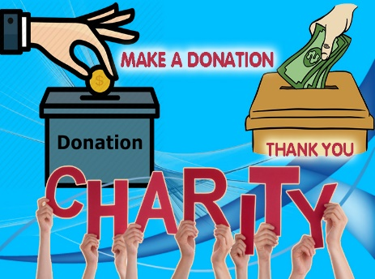

We are strong together! Donate Now & Be Part of Positive Change

- Flexible Sponsorship & Donation Deadline: Anytime a Year
- Year End Giving Donation Deadline: 31 December, 2022

Benefits & Privileges for Individual Donation: 10EUR above
- 10% discount for participation in one of the IPD program

Benefits & Privileges for Organizational Donation: 100EUR above
- 10% discount for participation of 1 representative in one of the IPD program

Benefits & Privileges for Bronze Sponsor: 1000EUR and above
- Upon request name & logo of Sponsor in the web page
- Table for promotion of product & services of Sponsor in one of the IPD event
- 10% discount for participation of 2 representatives of Sponsor in one of the IPD training program
- Stating logo & name of Sponsor in one of the IPD event publishing and promotional materials

Benefits & Privileges for Silver Sponsor: 5000EUR and above
- Upon request name & logo of Sponsor in the web page
- Table for promotion of product & services of Sponsor in one of the IPD event
- Free participation of 1 representative in one of the IPD training program or event
- 10% discount for participation of 2 representatives of Sponsor in one of the IPD training program or event
- Stating logo & name of Sponsor in one of the IPD event publishing and promotional materials

Benefits & Privileges for Gold Sponsor: 10000EUR and above
- Upon request name & logo of Sponsor in the web page
- Table for promotion of product & services of Sponsor in one of the IPD event
- Free participation of 2 representatives in one of the IPD training program or event
- 10% discount for participation of 3 representatives of Sponsor in one of the IPD training program or event
- Gala Dinner on behalf of the Sponsor for 1 of the IPD events participants
- Stating logo & name of Sponsor in one of the IPD event publishing and promotional materials
- Short video display of Sponsor during one of the IPD training program or events

Benefits & Privileges for Platinum Sponsor: 20000EUR and above
- Upon request name & logo of Sponsor in the web page
- Table for promotion of product & services of Sponsor in one of the IPD event
- Free participation of 3 representatives in one of the IPD training program or event
- 10% discount for participation of 3 representatives of Sponsor in one of the IPD training program or event
- Gala Dinner on behalf of the Sponsor for 1 of the IPD events participants
- Stating logo & name of Sponsor in one of the IPD event publishing and promotional materials
- Short video display of Sponsor during one of the IPD training program or events

Benefits & Privileges for Diamond Sponsor: 30000EUR and above
- Upon request name & logo of Sponsor in the web page
- Table for promotion of product & services of Sponsor in one of the IPD event
- Free participation of 5 representatives in one of the IPD training program or event
- 10% discount for participation of 5 representatives of Sponsor in one of the IPD training program or event
- Gala Dinner on behalf of the Sponsor for 1 of the IPD events participants
- Stating logo & name of Sponsor in one of the IPD event publishing and promotional materials
- Short video display of Sponsor during one of the IPD training program or events

Benefits & Privileges for Patronage Sponsor: Depending from Donation amount per month or per year

Short Questionnaires for Sponsors Registration
Please forward your answer to fhuseynli@ipdinstitute.ch (Sponsors Name will be Anonnymous)

1. Sex, Name & Surname (For Individual Donation):
2. Organisation Name (For Organisational Donation) & Contact Person name, surname/ position:
3. Country, City:
4. Your Position (If available):
5. Contact details (Personal or office email, WhatsApp, LinkedIn, Facebook & Skype)
6. Decided Sponsorship Amount:
7. Any proposal or suggestion?
8. I would like to Donate for Year End Giving Yes __________ USD / EUR / CHF

I would like to Donate every month Yes __________ USD / EUR / CHF per Month

I would like to Donate every year Yes __________ USD / EUR / CHF per Year

We give our deep thanks in advance for your respect, trust and
gift which is highly appreciated from our side.

Contact person for any questions

Mr. Fakhrinur Huseynli
Director
Institute for Peace and Dialogue (IPD)
Address: Ryffstrasse 23,
4056 Basel, Switzerland
E: fhuseynli@ipdinstitute.ch
www.ipdinstitute.ch
Cell/WhatsApp: +41 76 431 61 70
S: fakhrinur.huseynli
LinkedIn Profile: https://www.linkedin.com/in/fakhrinur-huseynli-574776223/

Like & follow us on Facebook

https://www.facebook.com/Institute-for-Peace-Dialogue-105141534911793/?ref=page_internal

