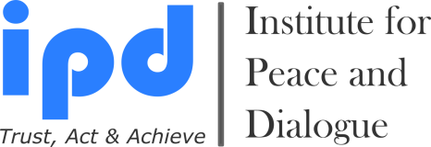

School of Diplomacy & International Relations

Training Courses in Diplomacy & International Relations

Dates: 5 - 11 January, 2026
- Early Bird Application Deadline: 15 September, 2025
- Late Application Deadline: 25 November, 2025

Venue: Basel, Switzerland

Portfolio Photo

APPLICATION

Personal Details

1. Name:
2. Surname:
3. Nationality:
4. Date of birth (dd.mm.yy):
5. Passport number:
6. Date of expire (dd.mm.yy):
7. Post address: (country, city, region, district, house, street, apart., zip code and etc.)

8. Office & Personal E-mail:
9. Cell / WhatsApp number (Please send invitation):
10. LinkedIn, Skype & Facebook addresses (Please send invitation):
11. Name of your School or Organization & Your Position (If available):
12. Reference Person (Name, surname, email, web page, tel. and etc.):
13. Relevant Embassy contacts: (E-mail address which we need to send invitation letter for visa process)
14. How did you hear about Training Course?
15. How you will cover your participation fee amount?
- Myself Yes
- My work or study place Yes
- Family member Yes
- Friend or Colleague Yes
- Other Sources (Please specify) Yes
Education If doesn’t exist please state N/A

Name & Email of University | Graduation Year | Degree Obtained

Work Experience If doesn’t exist please state N/A

Date:  mm/yyyy - mm/yyyy | Country | Name & Email of Company/Organization | Title of Position

Motivation for Participation (Not more than 500 words)

Special Needs

Do you have any special needs or requirements that the organizers should take into account during the Training Courses (e.g. dietary, vegetarian, disability, etc.)? Yes No If Yes Please specify

Please choose your Participation Fee payment options:

- Application Fee with Single Room: 1850EUR Yes
- Application Fee with Double Room: 1650EUR Yes
- Application Fee without Accommodation & Breakfast: 1000EUR Yes

B) Additional Expenses & Discounts

- Additional night stay in Single room includes breakfasts and local city transport ticket: Yes
- Additional night stay in Double room includes breakfasts and local city transport ticket: Yes

If yes please inform us how many Single or Double room stay nights you need before and after the training program to stay in our event or partner hotel ______Nights

- Welcome meeting in Basel Airport, Personal Driver and transfer to hotel: 130EUR per person Yes

- I am Alumni of IPD programs (10% discount) Yes
- I am student (10% discount) Yes
- I am small NGO representative (10% discount) Yes
- I am paying together with group of participants (More than 2 person for 10% discount) Yes
- I am ProPeace Member (For 10% discount please visit www.ipdinstitute.ch) Yes

Cancellation Rules & Procedure

Below stated high cancellation prices stated because of to prevent the mass application submission of non-serious people and prevent the financial risks of accommodation expenses.
Please note that after submission of the application, any participation cancellation until 3 October, 2025 the charge will be 750€ from the paid participation fee for the administrative charges.
For participation cancellation between 30 October and 15 December, 2025 the charge will be 1350€ (not including bank transfer and exchange rates costs) for the participants from the paid participation fee for the administrative charges.
For participation cancellation after 15 December, 2025, there will be no refund on the paid participation fee.
Participant responsible to inform IPD directly by email or post about his/her participation cancellation.

Bank Account Information to Transfer the Participation Fee

Beneficiary`s Name: Institute for Peace and Dialogue (IPD)
Bank Name: PostFinance Ltd
Bank Address: Mingerstrasse 20, 3030 Bern, Switzerland
Account number: 91-577724-2 EUR
IBAN: CH 27 0900 0000 9157 7724 2
SWIFT code: POFICHBEXXX

Declaration of the Applicant

By submitting this Application Form, I confirm that all the information given in this form is correct, true and complete. I also confirm that I agree to the following conditions of participation:

Yes I will actively join each of the activities during the training program.
Yes I understand that the organiser reserves the right to exclude the participant from the course in case information given in the form proves to be incorrect or because of misconduct at the training program.
Yes I confirm that I don’t have any refusal and grant IPD with irrevocable right using of my photos in IPD promotional works, materials and website for irrespective of time and place
Yes I will respect to other nations and race during the training program
Yes I confirm the participation cancellation rules & conditions

Name & Surname:

Date/Place:

Contact person for any questions:

Mr. Fakhrinur Huseynli
Director
Institute for Peace and Dialogue (IPD)
Address: Ryffstrasse 23,
4056 Basel, Switzerland
E: fhuseynli@ipdinstitute.ch
www.ipdinstitute.ch
Cell/WhatsApp: +41 76 431 6170
LinkedIn Profile: https://www.linkedin.com/in/fakhrinur-huseynli-574776223/

Follow us on Facebook
https://www.facebook.com/Institute-for-Peace-Dialogue-105141534911793/?ref=page_internal

If you have any problem to contact with us via your office email, then please try to write us via online contact form or via your personal email or via LinkedIn or via Skype and inform your
IT Department about the existed technical problem

We are looking forward to seeing you in our Diplomacy & International Relations

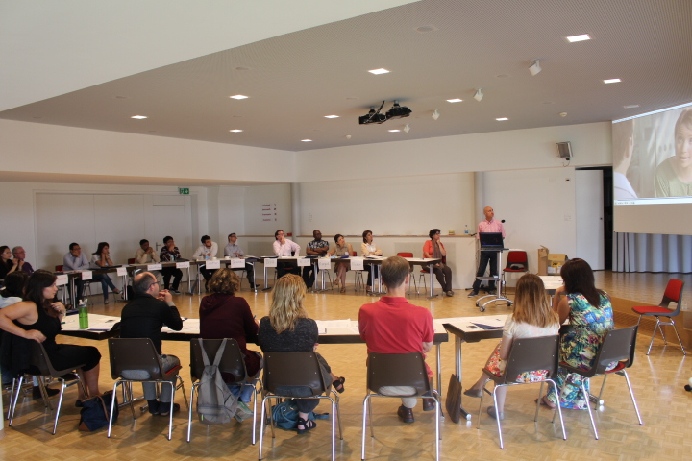
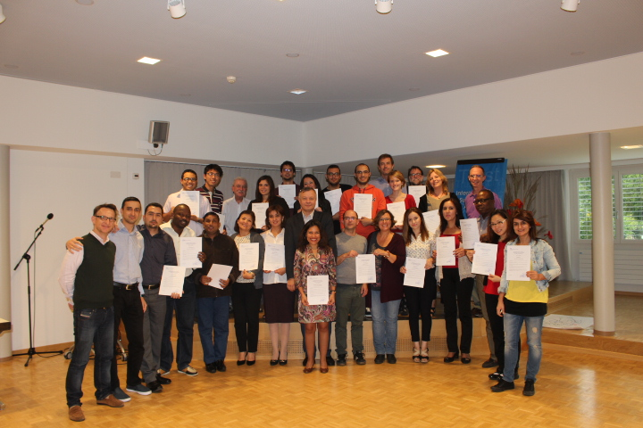

IPD Training Programs: Theory - Practice - Research - Exchange - Networking - Contribute

