School of Conflict Management, Cross Cultural Communication, Leadership, Mediation and Human Resources Management

Training Course: Peacebuilding, Conflict Intervention & Prevention, Mediation, Human Resources, Diversity, Equity & Inclusion & Leadership
Program Dates: 13 - 20 March, 2023 (Including arriving day, departure day, city walk and sightseeing activities)
Venue: Basel, Switzerland
Training Course Dates: 14, 15, 16 & 17 March, 2023
Sightseeing & Tour Dates: 18 & 19 March, 2023
Training Course Language: English
Registration Deadline: Until 15 February, 2023 by email registration form need to send to fhuseynli@ipdinstitute.ch or via LinkedIn in case of email communication doesn’t work well. We strongly suggest to applicants those need visa application process to apply as soon as possible.
Participation Fee: 2350EUR fee with Double room stay or 2650EUR fee with Single room stay or 1200EUR fee without Accommodation (Book your place until 1 February, 2023 & get 10% Discount)
Participation Fee Includes: Accommodation, breakfast, lunch, registration fee, certificate, invitation letter, course materials and stationary materials
Eligible Participants: Representatives of INGOs, NGOs, State, Public, Private & Academic Institutions, Students & Researchers
Scholarship Opportunities
- 10% discount for Alumni of IPD programs
- 10% Discount for registration until 1 February, 2023
- 10% discount for Students
- 10% discount for paying together with group of participants (More than 2 person)
- 10% discount for Annual ProPeac e Members (For registration please visit www.ipdinstitute.ch)

Registration Form (Please send in WORD file Format)

1. Name:
2. Surname:
3. Nationality:
4. Date of birth (DD.MM.YY):
5. Passport number:
6. Date of expire (DD.MM.YY):
7. Post address: (country, city, region, district, house, street, apart., zip code and etc.)
8. Office & Personal E-mail:
9. Cell number:
10. Skype & Facebook addresses:
11. Name of your School or Organization & Your Position (If available):
12. Reference Person (Name, surname, email, web page, tel. and etc.):
13. Relevant Embassy contacts: (E-mail address which we need to send invitation letter for visa process):
14. How did you hear about Training Program?
15. How you will cover your participation fee amount?
- Myself Yes
- My work or study place Yes
- Family member Yes
- Friend or Colleague Yes
- Other Sources (Please specify the financial aid source) Yes
16. Special Needs
Do you have any special needs or requirements that the organizers should take into account during the Program (e.g. dietary, vegetarian, disability, etc.)? Yes No If Yes Please specify
17. I would like to stay in Single Room Yes Double Room Yes

Declaration of the Applicant

By submitting this Application Form, I confirm that all the information given in this form is correct, true and complete. I also confirm that I agree to the following conditions of participation:

Yes I will actively join each of the activities during the training program.
Yes I understand that the organiser reserves the right to exclude the participant from the course in case information given in the form proves to be incorrect or because of misconduct at the training program.
Yes I confirm that I don’t have any refusal and grant IPD with irrevocable right using of my photos in IPD promotional works, materials and website for irrespective of time and place
Yes I will respect to other nations and race during the training program
Yes I confirm the participation cancellation rules & conditions

Name & Surname:

Date/Venue:

Contact person for any questions

Mr. Fakhrinur Huseynli
Director, Institute for Peace and Dialogue (IPD)
Address: Ryffstrasse 23,
4056 Basel, Switzerland
E: fhuseynli@ipdinstitute.ch
www.ipdinstitute.ch
Cell/WhatsApp: +41 76 431 6170
S: fakhrinur.huseynli
LinkedIn Profile: https://www.linkedin.com/in/fakhrinur-huseynli-574776223/

Like & follow us on Facebook
https://www.facebook.com/Institute-for-Peace-Dialogue-105141534911793/?ref=page_internal

If you have any problem to contact with us via your office email, then please try to write us via online contact form or via your personal email or via LinkedIn or Skype & inform your IT Department about the technical problem.

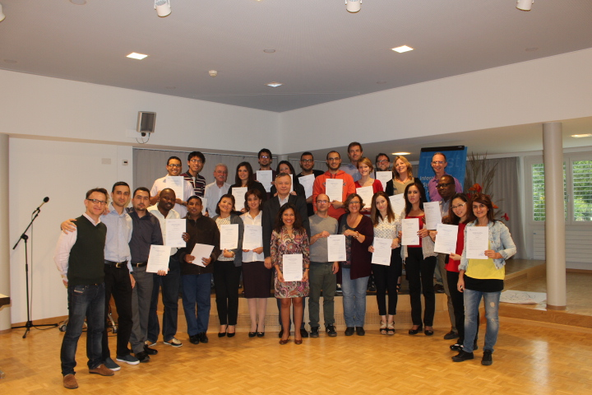

IPD Training Programs: Theory - Practice - Research - Exchange - Networking - Contribute

