BaselEduCa Expo 2023 - 4th International Education & Career Exhibition
Venue: Markthalle Basel, Switzerland
Dates: 18 - 19 April, 2023 (09:00 - 18:00)

Early Bird Application Deadline: 6 February, 2023 (Expired)
Extended Application Deadline: 4 April, 2023 Extended

Application

Scholarships, Job Opportunities, Fellowships, Research Programs, Degree Programs,
Language Courses, Exchange Opportunities, Internships, Building Cooperations,
Gap Programs, Trainings, Summer Camps

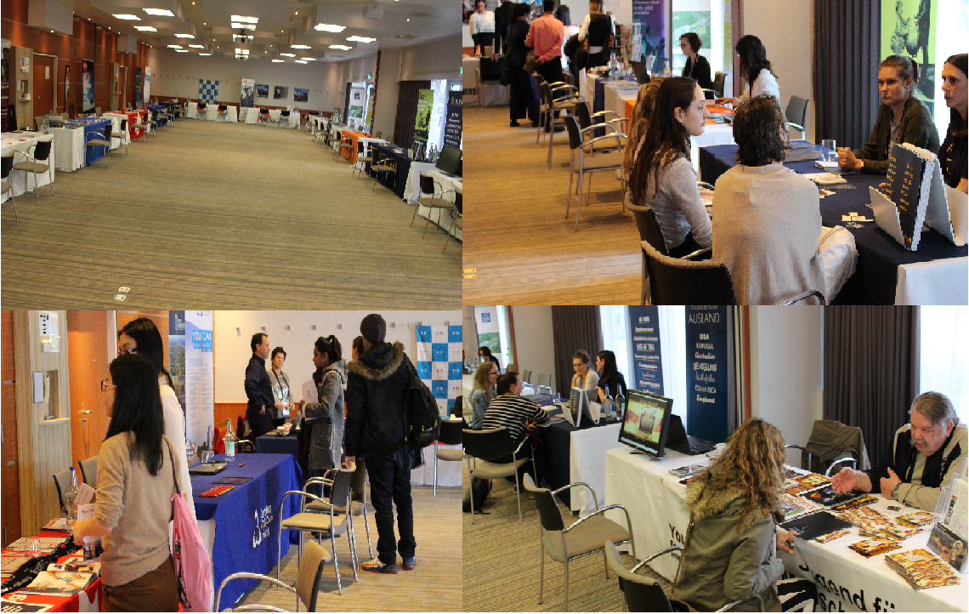

Exhibitor Logo
Whole name of the Exhibitor, Presenter,
Sponsor & Visitor

_____________________________________________

Please Select your Participation Type

- Exhibitor at 4th BaselEduCa Expo 2023 Yes
- Presenter at 4th BaselEduCa Expo 2023 Yes
- Sponsor of 4th BaselEduCa Exp 2023 Yes
- Visitor of 4th BaselEduCa Expo 2023 Yes

Representatives of the Exhibitor: Please contact us by email for registration of more representatives. Exhibitors also can inform us about accepted representatives’ information after submission of application before the deadline.

1st Representative | 2nd Representative
Sex (Male, Female) | Sex (Male, Female)
Name & Surname | Name & Surname
Date of birth: (If you need invitation letter for visa) | Date of birth: (If you need invitation letter for visa)
Passport ID: (If you need invitation letter for visa) | Passport ID: (If you need invitation letter for visa)
Date of expiry: (If you need invitation letter for visa) | Date of expiry: (If you need invitation letter for visa)
Office & Personal Email: | Office & Personal Email:
Cell number: | Cell number:
Special needs: | Special needs:
Position: | Position:
Full name and abbreviation of exhibitor
Website of exhibitor
Mail address of Exhibitor
Relevant embassy email: (If you need invitation letter for visa)
Contact Person Name, Surname, Position & Email

Please Choose Your Category as an Exhibitor

Governmental Institutions, Ministries and Departments working or offering educational, exchange, scholarship, research and career programs
Universities, Colleges, Schools and Research Institutions
Recruitment Agencies, HR Companies, Consulting Offices and Career Building Providers offering full or part time Jobs, Volunteership, Internship, Traineeship and Fellowship programs
Language and Foundation Course Centers
Apprenticeship Institutions, Vocational Education Provider and Training Centers
Study Abroad Agencies, Consultant Companies, Exchange and Study Programs Providers
Early year age education program providers, secondary and high schools
Summer and Winter Schools Program providers
Diplomatic Missions and Embassies/Consulates in Switzerland
INGOs, NGOs, Clubs and Associations working or offering educational, exchange, scholarship, research and career programs
Foundations and Philanthropies working or offering educational, exchange, scholarship, research and career programs
Companies and Commercial Institutions working or offering educational, exchange, scholarship, research and career programs
Research Institutes and Techno Parks
Distant Education program providers
Companies producing and selling school, laboratory, technology or stationary materials, accessories and equipment
Presenters of New Scientific Technologies and Innovation
Academic papers, education materials, teaching methodologies, books, magazines and research publishing presenters
Individual trainers, consultants, coachers and mediators
Teaching games/software/apps, musical instruments, drawing, gymnastic and sports equipment
Presenters of software, apps and special programs for HR, Team Development and Management
Office and library furniture, security systems and lighting system providers
Hotels and Centers offering seminar, conference and working venues
Mass Media
Others thinks are eligible to be exhibitor: Please specify

How did you hear about BaselEduCa Expo 2023?

Brief Introduction of the Exhibitor, Presenter, Sponsor or Visitor (Maximum 100 WORD for Exhibition Catalogue)

Education or Career Opportunities for BaselEduCa Expo 2023

Degree and non-degree programs (Please specify)
Job & career opportunities (Please specify)
Research, exchange & fellowship programs (Please specify)
Foundation or Preparation Programs (Please specify)
Summer and Winter Schools (Please specify)
Language courses (Please specify)
Conferences and Trainings (Please specify)
Apprenticeship Education (Please specify)
Early year age education programs (Please specify)
Elementary & high schools programs (Please specify)
Financial Support or Scholarship for Educational Programs
Others (Please specify)

Participation Fee & Price List for Extra Services

A) Early Bird Application Fee Deadline until 6 February, 2023 - Expired
- 1650EUR for 4 sqm. (2 x 2 m) space Yes
- 2300EUR for 9 sqm. (3 x 3 m) space Yes
- 2950EUR for 12 sqm. (3 x 4 m) space Yes

C) Extended Application Fee Deadline until 4 April, 2023
- 2050EUR for 4 sqm. (2 x 2 m) space Yes
- 2700EUR for 9 sqm. (3 x 3 m) space Yes
- 3350EUR for 12 sqm. (3 x 4 m) space Yes

B) Remote Participation is 700EUR (4 sqm. space) Yes
C) Extra Service Expenses: Un-refundable

- Additional Expo space: Price upon request Yes
- Individual Translator (English-German or English-French): 80EUR per hour Yes
- Exhibitors accompanying fee during the exhibition: 50EUR per hour Yes
- Airport transfer fee (include transport fee): 100EUR for one way Yes

- Advertisement in Expo Catalogue (Full Page)
A) Colourful, A5 Format, Vertical: 1500EUR for Back Cover Yes
B) Colourful, A5 Format, Vertical: 750EUR for Inside of Catalogue Yes

- Accommodation prices per night
A) Single room: 175EUR per person include breakfast, BaselCard, WiFi and city tax Yes
B) Double room: 135EUR per person/night include breakfast, BaselCard, WiFi and city tax Yes

- Presentation at BaselEduCa Expo Presentation
A) 30 min. Presentation + Q & A Session + Apero Session: 700EUR Yes
B) 50 min. Presentation + Q & A Session + Apero Session: 900EUR Yes

- Extra exhibitor representatives’ participation: 230EUR per person (include invitation letter, 2 times lunch, coffee, exhibition badge and registration) Yes

- Visitor Expenses for Invitation Letter Sending: 180EUR per person Yes

Please choose type of your Donation/Sponsorship

For Individual Donation: 10EUR and above
For Organizational Donation: 50EUR and above
To be Bronze Sponsor: 1000EUR and above
To be Silver Sponsor: 5000EUR and above
To be Gold Sponsor: 10000EUR and above
To be Platinum Sponsor: 20000EUR and above

To be Diamond Sponsor: 30000EUR and above
Gala Dinner Sponsorship during the Opening Ceremony: 10000EUR
Coffee Break Sponsorship for Exhibitors during 2 days Exhibition: 5000EUR
Sponsorship for Exhibition T-shirt & Caps (1000 pieces): 10000EUR
Sponsorship for Exhibition Umbrella (1000 pieces): 15000EUR
Sponsorship for Exhibition USB Stick (1000 pieces): 10000EUR
Sponsorship for Exhibition Pen Sponsorship (1000 pieces): 10000EUR
Sponsorship for Exhibition Notebook (1000 pieces) 10000EUR
Sponsorship for Exhibition Package (1000 pieces) 10000EUR
Sponsorship for Student Jug (1000 pieces) 10000EUR
Other desired Sponsorship amount

Do you need a Visa to Travel to Switzerland? Yes No

Cancellation Rules and Deadline for New Exhibitors

Cancellation of participation till the 10 March, 2023 there will be cancellation charge 50% of the participation fee. Cancellation appeals after 10 March, 2023 are non-refundable.
Participant responsible to inform IPD directly by email or post about his/her participation cancellation.

Bank Details for the Payment

Beneficiary`s Name: Institute for Peace and Dialogue (IPD)
Bank Name: PostFinance Ltd
Bank Address: Mingerstrasse 20, 3030 Bern, Switzerland
Account number: 91-577724-2 EUR
IBAN: CH 27 0900 0000 9157 7724 2
SWIFT code: POFICHBEXXX

PS: After submission of filled application please wait IPD payment invoice document to proceed the requested fee payment transaction documents.

Declaration of the Applicant

By submitting this Application Form, I confirm that all the information given in this form is correct, true and complete. I also confirm that I agree to the following conditions of participation:

- I understand that the organiser reserves the right to exclude the participant from the participation in case information given in the form proves to be incorrect or because of misconduct at the program.
- I confirm that I don’t have refusal on using my photos in IPD promotional materials and website
- I will respect to other nations and race during the participation
- I confirm the participation cancellation rules & conditions

Name & Surname:

Position:

Date/Place:

Contact US

E: baseleducaexpo@ipdinstitute.ch
Tel. / WhatsApp: +41764316170
Address: Ryffstrasse 23,
4056 Basel, Switzerland
www.ipdinstitute.ch

If you have any problem to contact with us via your office email, then please try to write us
via online contact form or via your personal email or via Skype or LinkedIn and inform your
IT Department about the technical problem.

We will be happy to cooperate with your Institution
& welcome you in our BaselEduCa Expo 2023 Event

