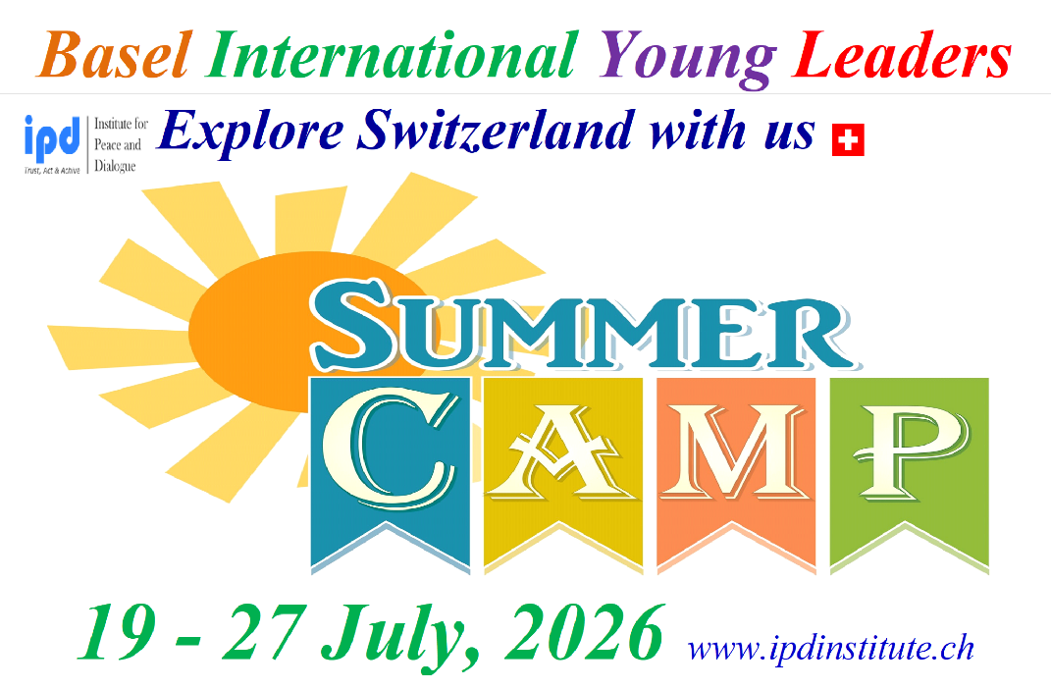

Registration Form

Early Bird Registration Deadline: 25 March, 2026

Late Application Deadline: 10 June, 2026

Venue: Basel, Switzerland + Visiting France, Germany, Geneva, Bern & Luzern


Leadership Training + Networking + Explore Switzerland with us

- Sex (Male or Female):

- Name:

- Surname:

- Date of Birth:

- Place of Birth:

- Passport Number:

- Date of issues:

- Date of expire:

- Place of issues:

- Address (Postal Code, Country, City, Region, Settlement, Street, Building, Home, Apartment etc.):

- Cell Number of Participant, Parent & Legal Guardian:

- Personal Email address of Participant, Parent & Legal Guardian:

- LinkedIn address

- School Name & email address for emergency contact:

- Are you traveling with legal guardian (If you are under 18)? Please specify with whom you are planning to travel includes Name, Surname, Cell Number, LinkedIn & Email Address:

- Your planned arriving day to Hotel: DD/MM/YYYY

- Your planned departure day from Hotel: DD/MM/YYYY

- Embassy email address if you need visa:

- How did you hear about Basel Young Leaders Summer Camp 2025?

- Do you have any special needs or requirements that the organizers should take into account during the Basel Summer Camp (e.g. dietary, vegetarian, disability, etc.)? Yes No If Yes Please specify

- 10% discount for Alumni of IPD programs Yes
- 10 % discount for disadvantages youth & students Yes
- 10% discounts for small NGO representatives (Valid with Organizational Reference Letter) Yes
- 10% discount for paying together with group of participants (More than 2 person) Yes
- 10% discount for Annual ProPeace Members (For registration please visit www.ipdinstitute.ch) Yes

Please state your desired participation fee payment type

- Early Bird Application Fee with Single Room: 2650EUR Yes
- Early Bird Application Fee with Double Room: 2050EUR Yes
- Early Bird Application Fee without Accommodation & Breakfast: 1250EUR Yes

- Late Application Fee with Single Room: 2900EUR Yes
- Late Application Fee with Double Room: 2300EUR Yes
- Late Application Fee without Accommodation & Breakfast: 1550ER Yes

- Basel city Airport transfers: 120EUR per person for 1 way Yes

- Additional Accommodation Stay: 155EUR per person per night in Single room includes breakfast, city tax and free local city travel card Yes

- Participation of Legal Guardian of Children: 1900EUR per person includes accommodation in Single room stay, invitation letter, breakfast, lunch & dinner with group & free local city travel card Yes

I confirm my participation and agree with the participation fee payment and cancellation conditions stated in Infopack Yes

PS: Please copy participant and legal guardian passport page to the email when you submit the filled registration form

Name & Surname of Participant:

Name & Surname of Legal Guardian (for applicants under 18 year old):

Date/Venue:

Contact person

Fakhrinur Huseynli
Institute for Peace & Dialogue (IPD)
Address: Ryffstrasse 23,
4056 Basel, Switzerland
Cell / WhatsApp: +41 76 431 61 70
E: fhuseynli@ipdinstitute.ch
www.ipdinstitute.ch
LinkedIn: https://www.linkedin.com/in/fakhrinur-huseynli-574776223/

If you have any problem to contact with us via your office email, then please try to write us via online contact form or via your personal email or via LinkedIn or via Skype and inform your
IT Department about the existed technical problem.

We are looking forward to seeing you in our Basel Young Leaders Summer Camp 2026

Follow us on Facebook
https://www.facebook.com/Institute-for-Peace-Dialogue-105141534911793/?ref=page_internal

