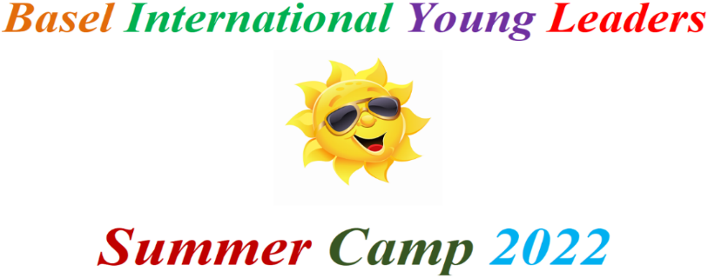
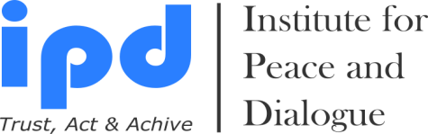

Summer Camp: 11- 20 July, 2022

Early Bird Registration & Payment Deadline: 25 April, 2022

Final Application & Payment Deadline: 1 June, 2022

Venue: Basel, Switzerland

Registration Form

- Sex (Male or Female):

- Name:

- Surname:

- Date of Birth:

- Place of Birth:

- Passport Number:

- Date of issues:

- Date of expire:

- Place of issues:

- Address (Postal Code, Country, City, Region, Settlement, Street, Building, Home, Apartment etc.):

- Cell Number of Participant, Parent & Legal Guardian:

- Personal Email address of Participant, Parent & Legal Guardian:

- School Name & email address for emergency contact:

- What is your English language level? A1, A2, B1, B2, C1 & C2

- Are you traveling with legal guardian? Please specify with whom you are planning to travel includes Name & Surname:

- Embassy email address if you need visa:

- How did you hear about Summer Camp 2022?

- Do you have any special needs or requirements that the organizers should take into account during the Summer Program (e.g. dietary, vegetarian, disability, etc.)? Yes No If Yes Please specify

- I am Alumni of IPD programs (10% discount) Yes
- I am paying together with group of participants (More than 2 person for 10% discount) Yes
- I am ProPeace Member (For 10% discount please visit www.ipdinstitute.ch) Yes

- Please state your desired participation fee payment type

- 2950EUR per person with Single room stay includes 3 times meals, program fee, sightseeing trips, activities, invitation, free local city travel card, certification & registration fee
Yes

- 2650EUR per person with Double room stay (2 participants in 1 room) includes 3 times meals, program fee, sightseeing trips, activities, invitation, free local city travel card, certification & registration fee
Yes

- 2350EUR per person with Triple room stay (3 participants in 1 room) includes 3 times meals, program fee, sightseeing trips, activities, invitation, free local city travel card, certification & registration fee
Yes

- 2050EUR per person for 4 participants in 1 room stay includes 3 times meals, program fee, sightseeing trips, activities, invitation, free local city travel card, certification & registration fee
Yes

- Airport transfers: 100EUR per person for 1 way Yes

- Additional Accommodation Stay: 150EUR per person per night in Single room includes breakfast and free local city travel card Yes

- Participation of Legal Guardian of Children: 2150EUR per person includes accommodation in Single room stay, invitation letter, breakfast, lunch & dinner with group & free local city travel card Yes

I confirm my participation and agree with the participation fee payment and cancellation conditions stated in Infopack Yes

PS: Please copy participant and legal guardian passport page to the email when you submit the filled registration form

Name & Surname of Participant:

Name & Surname of Legal Guardian:

Date/Venue:

Contact person

Fakhrinur Huseynli
Institute for Peace & Dialogue (IPD)
Address: Ryffstrasse 23,
4056 Basel, Switzerland
Cell / WhatsApp: +41 76 431 61 70
E: fhuseynli@ipdinstitute.ch
www.ipdinstitute.ch

If you have any problem to contact with us via your office email, then please try to write us via online contact form or via your personal email or via Skype and inform your IT Department about the technical problem.

Follow us on Facebook
https://www.facebook.com/Institute-for-Peace-Dialogue-105141534911793/?ref=page_internal

Thank you very much joining our Summer Camp 2022

