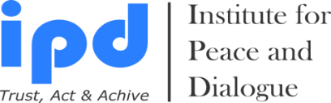

Summer Exchange Trip to Azerbaijan
3 Cities: Baku - Guba - Astara

Summer Exchange Trip Dates: 16 - 22 September, 2023

Early Bird Payment Registration Deadline: 26 June, 2023
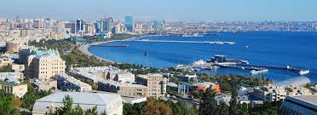
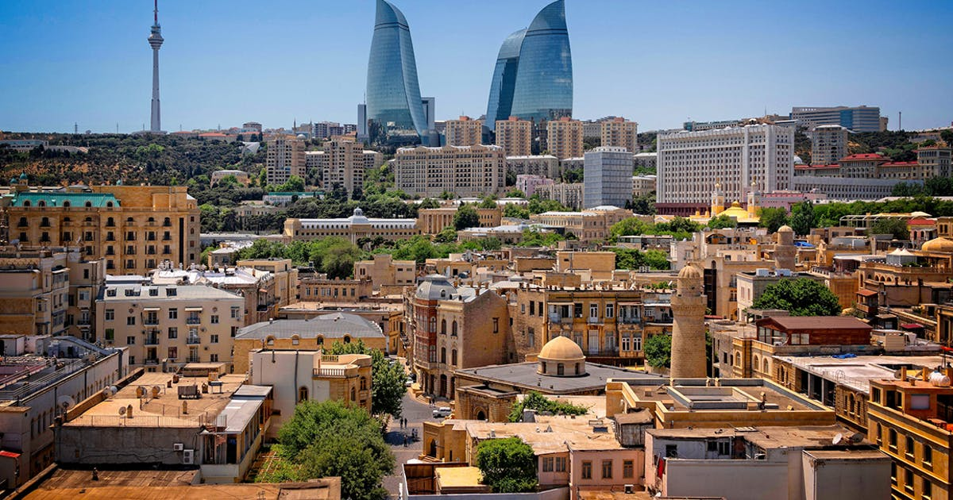
Final Registration Payment Deadline: 24 July, 2023

Registration Form
(Please attach your passport page to the email for Hotel Booking)

- Sex (Male or Female):

- Name:

- Surname:

- Date of Birth:

- Place of Birth:

- Passport Number:

- Date of issues:

- Date of expire:

- Place of issues:

- Address (Postal Code, Country, City, Region, Settlement, Street, Building, Home, Apartment etc.):

- Cell / WhatsApp Number:

- Personal & Office Email:

- Have you been before in Azerbaijan, Armenia or Georgia?

- Do you need visa to enter Azerbaijan Republic?

- If you are less than 18 year old then are you traveling with legal guardian? Please specify with whom you are planning to travel.

- Do you wish IPD book for your additional night stay in Azerbaijan? If yes please state intended arriving and departure days

- Are you plan to travel with your family members? If yes how many family members wish to travel and they age?

- Are you plan to apply as a group? If yes how many group members do you have and they age?

- When is your intended Arriving & Departure Day? DD/MM – DD/MM

- I wish to pay until 26 June, 2023 Early Bird Payment Registration: 1900 EUR / Person Yes
- I wish to pay until 24 July, 2023 Final Application Deadline: 2250 EUR / Person Yes

- I am Alumni of IPD programs (10% discount) Yes
- I am student (10% discount) Yes
- I am paying together with group of participants or Family (More than 2 person for 10% discount) Yes
- I am paying together with group of participants or Family (More than 6 person for 20% discount) Yes
- I am ProPeace Member (For 10% discount please visit www.ipdinstitute.ch) Yes

Bank Account Information to Transfer the Participation Fee (After Receiving Payment Invoice)

Beneficiary`s Name: Institute for Peace and Dialogue (IPD)
Bank Name: PostFinance Ltd
Bank Address: Mingerstrasse 20, 3030 Bern, Switzerland
Account number: 91-577724-2 EUR
IBAN: CH 27 0900 0000 9157 7724 2
SWIFT code: POFICHBEXXX

I read and agree with the program dates, activities, cancellation conditions and understand paid participation fee is un-refundable Yes

Name & Surname:

Date/Venue:

Contact person

Mr. Fakhrinur Huseynli
Director
Institute for Peace and Dialogue (IPD)
Address: Ryffstrasse 23,
4056 Basel, Switzerland
Cell / WhatsApp number: +41 76 431 6170
E: fhuseynli@ipdinstitute.ch
www.ipdinstitute.ch
LinkedIn Profile: https://www.linkedin.com/in/fakhrinur-huseynli-574776223/

Thank you very much for joining our Summer Exchange Trip
to Discover new Culture and Places with Us

If you have any problem to contact with us via your office email, then please try to write us via online contact form or via your personal email or via Skype or LinkedIn and inform your IT Department about the technical problem.

Follow us on Facebook
https://www.facebook.com/Institute-for-Peace-Dialogue-105141534911793/?ref=page_internal

